05_ACCESSIBILITY_BESTSONG_EXTRA
Upon launching the program, the screen shown below is displayed. On the right, we have the Accessibility button; clicking it opens a panel that allows us to select various options.
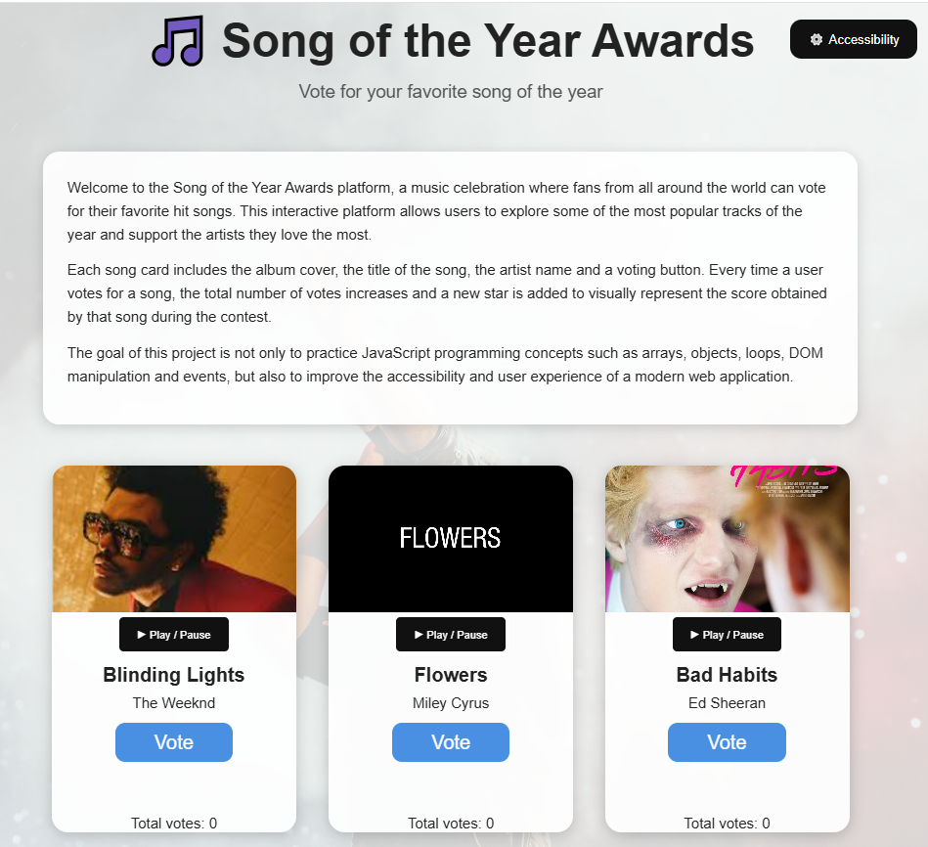
If we change the font size, the text inside the white div is modified. 'Readable text' increases the letter spacing of the text.
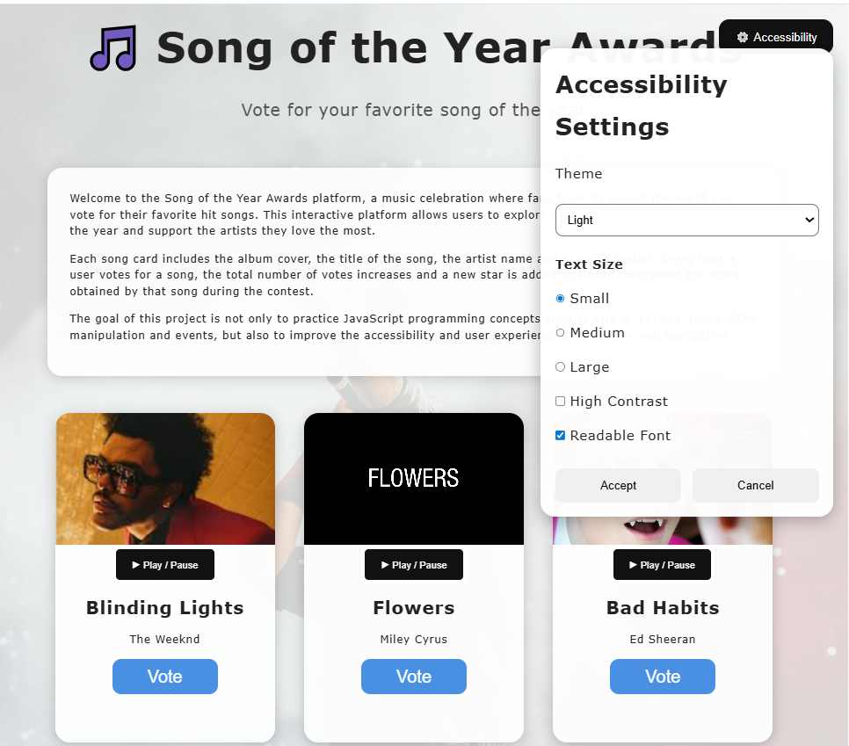
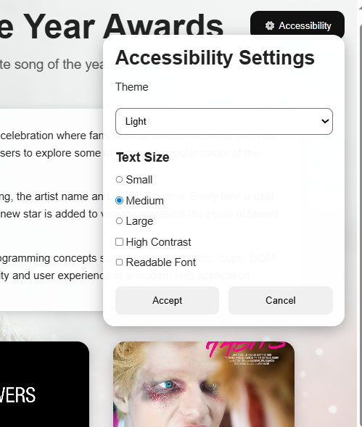

'Dark mode' sets the background to black and the rest of the elements as seen in the figure.
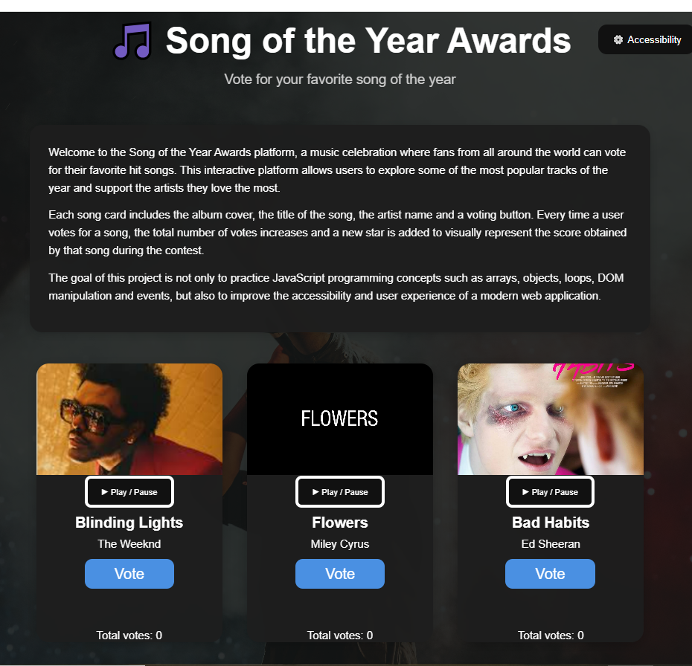
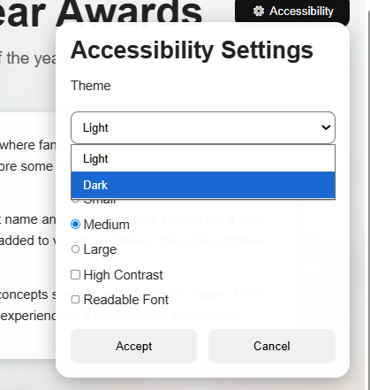

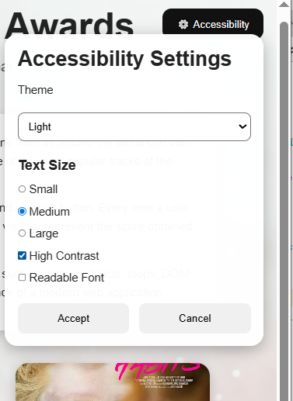
'High contrast' changes the colors to black and yellow, as shown in the figure
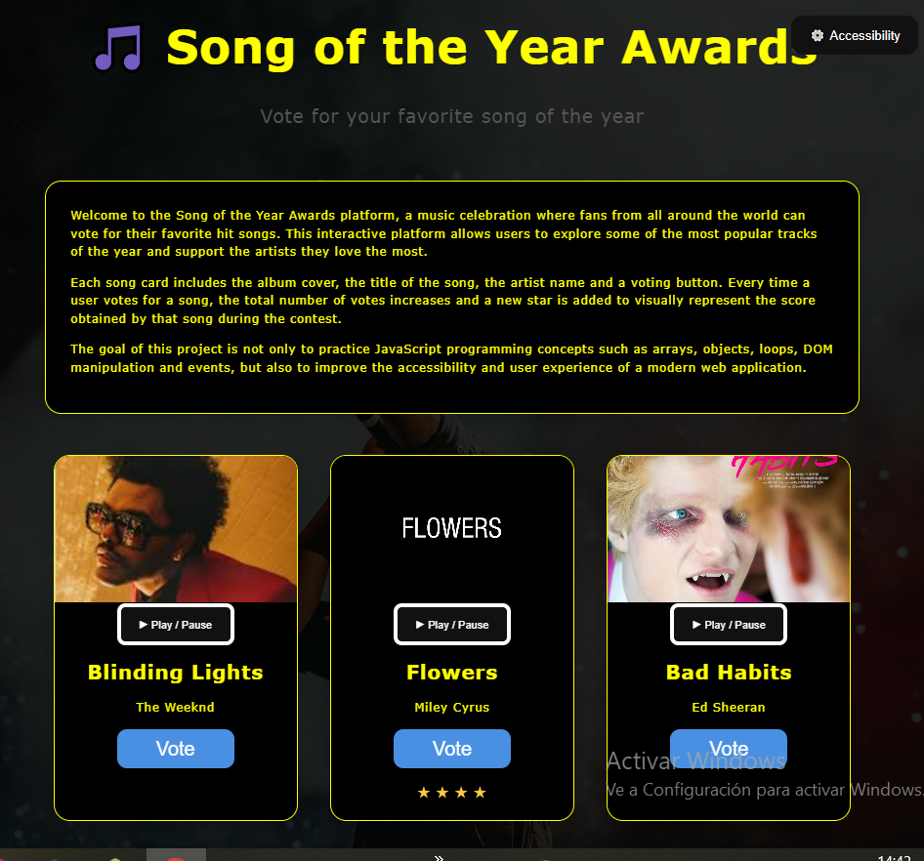

Clicking the Play/Pause button starts playing the song's audio. If there is any other audio playing, it pauses it. Clicking the button again pauses the sound playback.
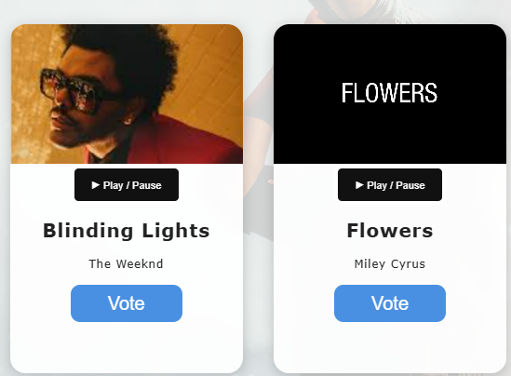
The 'Vote' button adds a vote to the song and adds a star at the bottom.
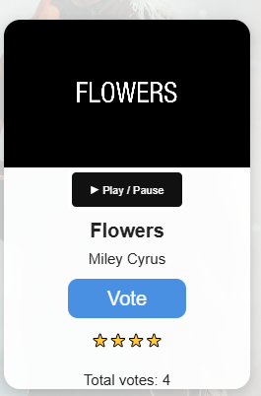
const songs = [
{ id: 1,
title: "Blinding Lights",
artist: "The Weeknd",
cover: "images/The weekendBlindingLights.png",
sound: "audio/The_Weeknd_BlindingLights.mp3",
votes: 0
},
{
id: 2,
title: "Flowers",
artist: "Miley Cyrus",
cover: "images/Miley_Cyrus_Flowers.png",
sound: "audio/Miley_Cyrus_Flowers.MP3",
votes: 0
},
{
id: 3,
title: "Bad Habits",
artist: "Ed Sheeran",
cover: "images/edSheeranBadHabits_.jpg",
sound: "audio/Ed_Sheeran_ Bad_Habits.MP3",
votes: 0
},
{
id: 4,
title: "Levitating",
artist: "Dua Lipa",
cover: "images/duaLipaLevitating.jpg",
sound: "audio/Dua_Lipa_Levitating.MP3",
votes: 0
},
{ id: 5,
title: "As It Was",
artist: "Harry Styles",
cover: "images/As_It_was.png",
sound: "audio/Harry_Styles_As_It_Was.MP3",
votes: 0
}
];

